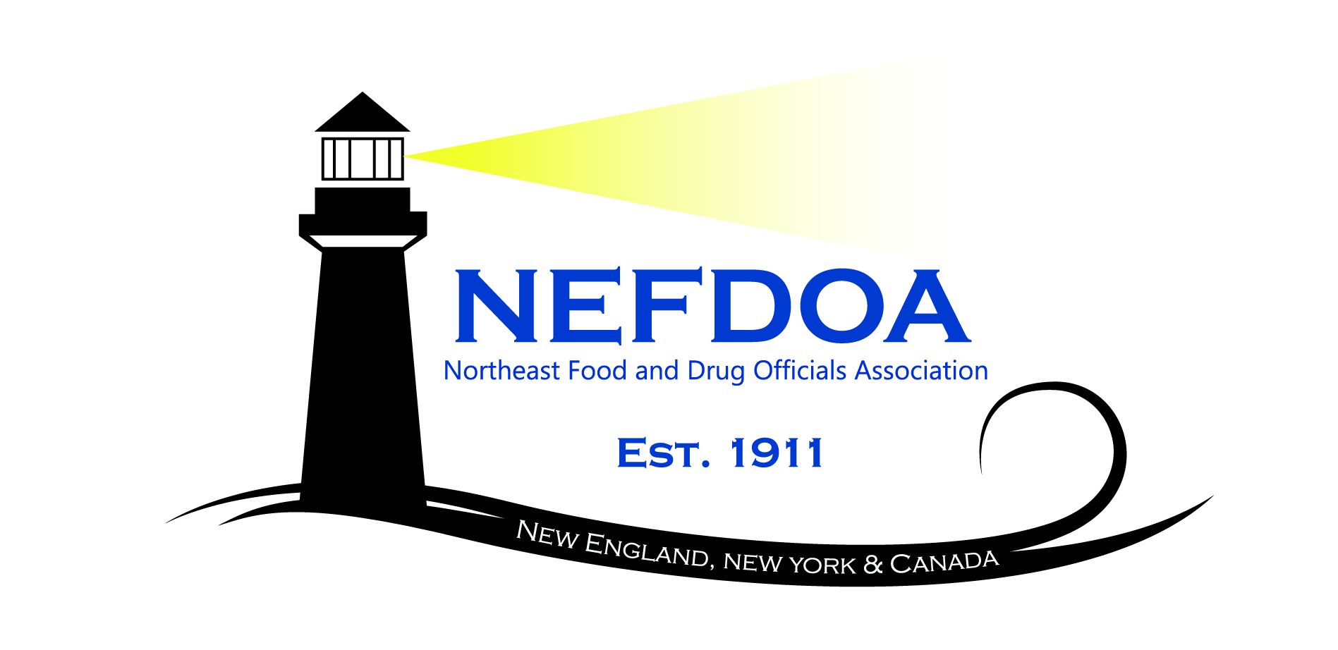

Northeast Food and Drug Officials Association (NEFDOA) Educational Conference

October 22-23, 2026
Hotel Northampton
Northampton, MA

Thursday, October 22, 2026
7:00 – 8:00 am | Registration │ Location: TBD
7:00 – 8:00 am | Continental Breakfast│ Location: TBD
Silent Auction Opens │Location: Atrium
Moderator: Tom Nerney, FDA Retail Food Specialist, FDA
 | Moderator:
8:00 am – 8:15 am | Welcome to the 114th NEFDOA Educational Conference  Gwen Williams, NEFDOA President, VT Department of Health
8:15 am – 9:00 am | USDA FSIS Update  Thomas Collaro, Deputy Regional Director, U.S. Department of Agriculture, Food Safety and Inspection Service, Office of Investigation, Enforcement and Audit
9:00 am – 10:00 am | Driving Food Safety and Quality Improvements with Power BI Analytics  Phil Kemp, Director ADUSA &  David Villagomez, ADUSA Western Division
10:00 – 10:15 | Break
10:15 am – 11:15 am | Closer to Zero Initiative  Victoria Incorvati, Ph.D, Chemist, Human Foods Program, U.S. Food and Drug Adminstration
11:15 am – 12:00 pm | A Tale of Two Campylobacter and a Vibrio Outbreak from Maine Oysters  Kohl Kanwit, Director, Bureau of Public Health and Aquaculture, Maine Department of Marine Resources
12:00 pm – 1:30 pm | Lunch Break (on your own)
1:30 pm – 2:00 pm | No Water/Boil Water/No Hot Water Panel Discussion  Frank Greene, State of CT, Jenna Nicol, Environmental Health Section Chief, CT DPH, Michael Moore, State of MA, Dan McCarthy and Jessica Egan, State of NY, Gwen Williams, State of VT, other states TBD
2:30 pm – 3:30 pm | AFDO President’s Update  Brad Deacon, Director of Office of Legal Affairs & Emergency Management, MI Department of Agriculture and Rural Development (MDARD)
3:30 pm – 3:45 pm | Break │
3:45 pm – 4:30 pm | Indian Health Services Presentation  LCDR Riley Grinnell, REHS, CP-FS, MPH (Dec. 2026)  Environmental Health Office, Nashville Area Indian Health Service
4:30 pm | Closing Remarks & Daily Adjourn
6:00 PM | Networking Event & Silent Auction

Friday, October 23, 2026
7:00 – 8:00 am | Registration │ Location: Prefunction  Continental Breakfast│ Location: Prefunction  Exhibitor Showcase │ Location: Prefunction
 | Moderator: TBD
8:00 am – 8:45 am | Update on FDA’s Office of Inspections and Investigations  Glenn Bass, Acting Director, Office of Human Food Inspectorate-East &  Ronald Pace, Director, Division of Human Food Inspectorate, East 1.
8:45 am – 9:30 am | Drugs vs. Supplements  Siobhan Gallagher Taylor, FDA Dietary Supplement Nutritional Expert
9:30 am – 10:15 am | Allergen Cross-Contact in Retail: Understanding the Risks, Challenges and Solutions  Ellen Boyer, CP-FS, Manager, Retail Food Safety and Regulatory Compliance, Quality Assurance Division, Wakefern
10:15 am – 10:30 am | Break
10:30 am – 11:30 am | AI Impacts on Food Safety  Bruno Miereles Xavier, Ph.D, Senior Extension Assoicate/Process Authority, Cornell Food Venture Centure, Cornell University
11:30 am – 12:00 pm | Closing Remarks & Adjournment
12:00 pm – 12:30 pm | NEFDOA Board Meeting

Contact hours available on request
Silent Auction donations welcome, receipts for donations available Nvcx

